Rotary Turntable Shrink Sleeve Labeling Machine for Medical Adhesive Tape ZRM-1212C
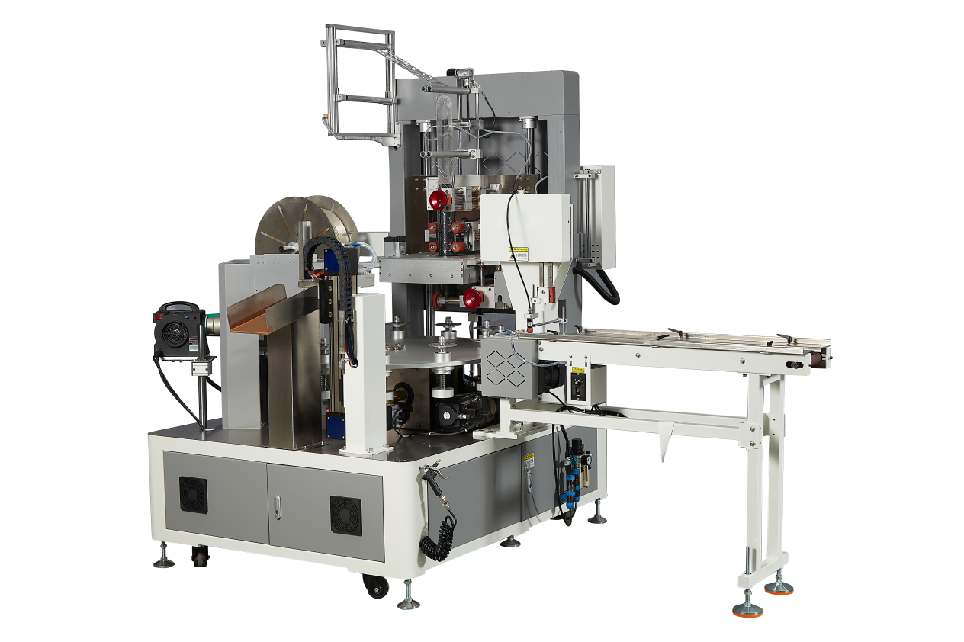
Equipment Layout：
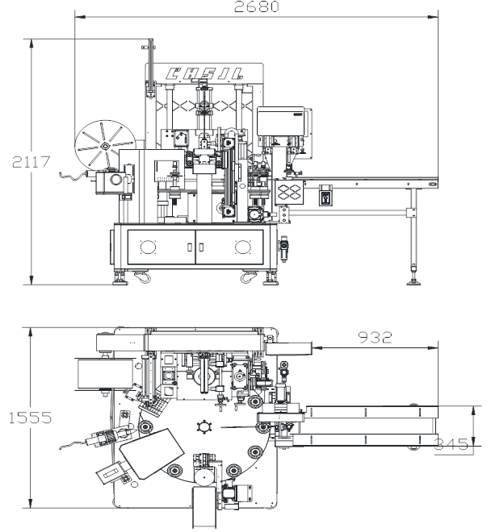
Basic Use：
It is mainly used for shrink film packaging of various medical adhesive tapes.

Advantages of the equipment：
- The equipment is equipped with a PPU mechanical arm for automatic material loading.
- Human-machine interface, microcomputer programmable control
- Four-servo control system: The turntable is driven by a servo motor for high-precision transmission. Servo-controlled film feeding: allows for adjustable length settings, precise cutting, and seamless sleeving. Stable performance: The blade is precisely controlled by a servo system for accurate film cutting.
- The positioning structure is driven by a high-precision indexing device. With a 12-division structure, the servo motor drives a large plate with 12 working positions, which then proceeds to the film winding position.
- The operation is simple. In case of a fault, an automatic alarm will be triggered. It can be operated intelligently with just one click.
- Constant temperature adjustable temperature control system.
- The mold replacement is convenient and quick.
- Rotating disc structure, compact and lightweight
- The imported hot air gun heats up steadily and is durable.

Main technical parameters：
Model | Rotary Turntable Shrink Sleeve Labeling Machine for Medical Adhesive Tape ZRM-1212C
Packaging width | 15-100mm
Packaging diameter | 50-90mm  （Can be customized as needed）
Packaging speed | 35-40 pcs /分钟minutes
Voltage and power | AC380V-4P 7.5KW
Atmospheric pressure | 0.5mpa
Packaging film thickness | 0.035-0.04mm（Shrinkage rate50%）
Machine size | 3000mm*1800mm*2500mm
Net weight | 1500KG
Configuration parameters：
Model | Rotary Turntable Shrink Sleeve Labeling Machine for Medical Adhesive Tape STM-1212C
Touchscreen | Display control
Turntable servo | HOKAWA
Rotary drive unit | HOKAWA
Film delivery servo | HOKAWA
Film delivery drive | HOKAWA
Film cutting servo system | HOKAWA
Film cutting drive | HOKAWA
Reducer | Smart
Smart Indexer | JUJIU
PLC Controller | Hokawa
Air switch | Zhengtai
Contactor | Schneider
Switching power supply | Mingwei
Speed control motor | Yongli
Photoelectric switch | Yangming
Solid-state relay | Yangming
Relay | Koizumi
Thermostat | Tatsuzumi
Frequency converter | Kosovo
Push-button switch | Schneider
Cylinder | star
Filter | Tiangong
Solenoid valve | Tiangong
Magnetic switch | Yadek
Bearing | NSK
Rack | Imported powder coating
Optical fiber amplifier | Boyi
Motion controller | Hokawa
Photoelectric sensor | Boyi
Reducer | Mai Li
Hot air gun | HERZ Imported
Guide rail | HiWIN

